Title: Times New Roman (Font size: 23)

Author: First Author¹․Second Author² (Font: Times New Roman, Font size: 12)

Abstract
(Times New Roman, font size: 9.5)
Up to 150 words (approx.). This must be concise and must not include any references.
1. The authors are expected to be the members of the Korean Institute of Electromagnetic Engineering and Science except for some special ones approved by the editorial board of KIEES. 2. A manuscript submitted for publication in JEES should be an original work that contributes to the academic interests of the KIEES members with technical values. 3. It must not have been previously published and is not to be under consideration for publication elsewhere. Responsibility for the contents of published papers rests upon the authors, not the JEES. 4. A paper manuscript can be submitted any time and the date of the receipt is the one on which the editorial office of the KIEES receives it. A revised paper manuscript should be submitted to the editorial office within one month from the date on which any change of the paper manuscript is requested to the author. If not, its initial date of receipt shall be nullified.
Key Words: About Five key words or phrases in alphabetical order, separated by commas.

http://dx.doi.org/10.5515/JKIEES.000.00.0.0
ISSN 2234-8395 (online) ∙ ISSN 2234-8409 (Print)

Ⅰ. INTRODUCTION
(Times New Roman, Font size: 10.5)
5. The title of each paper is expected to cover the whole contents of the paper and it should be as concise as possible.
6. Publication of papers is subject to the sole decision of the editorial board. The editorial board may request corrections or shortening of the manuscript and may make inquiries to the author.
7. A cover of each paper manuscript should include a title, authors’ names (main author and co-authors), author’s organizations, contact information (email
Manuscript received October 00, 0000 ; Revised December 00 ; Accepted January 00, 0000. (ID No. 00000000-000J)
¹Department, University, Region, Country.
²Company, Region, Country.
Corresponding Author: JEES (e-mail: hyej80@kiees.or.kr)
This is an Open-Access article distributed under the terms of the Creative Commons Attribution Non-Commercial License (http://creativecommons.org/licenses/ by-nc/3.0) which permits unrestricted non-commercial use, distribution, and reproduction in any medium, provided the original work is properly cited.

address), and the author’s area of expertise. The first page of a main text should only contain title, abstract with a length of about 150 words, and key-words with around five words.
8. Each paper should be written in A4 and be submitted in MS-Word format (use the JEES’ template). The paper should also be written within 12 pages (with a two-column format) including figures, charts, and tables.
9. The numbers corresponding to chapters in the paper should be written in Roman numerals (I, II, III, IV...) and the numbers corresponding to sections should be written in Arabic numerals (1, 2, 3, 4...).
10. The contents of the paper should be arranged in the order of abstract, main text, references, and appendix.
11. Equation numbers should be given in Arabic numerals enclosed in parentheses on the right-hand margin. They should be cited in the text as, for example Eq. (1) or Eqs. (1)-(3).
12. All tables should be numbered consecutively with Arabic numerals. They should be referred to in the text and should be numbered according to their order of mention in the text. In addition, all tables should, not only list all abbreviations in the table in footnotes at the end, but also have a title that is concise and describes the table’s contents. Vertical lines are not used. The table should be self-explanatory and supplement, not duplicate, the text. If the table or any data therein have been published, a footnote to the table must give permission information to the original source. The structure should be clear, with simple column headings giving all units. A table should not exceed one page when printed. Use lowercase letters in superscripts ^{a,b,c...} for special remarks.
13. All figures should be of high quality meeting with the publishing requirement with legible symbols and legends. In preparing the figures, authors should consider a size reduction during the printing process to have acceptable line clarity and character sizes. Use only figures that are necessary to illustrate the meaning of the text. Figures must be black and white of high contrast. All figures should be referred to in the text as, for example, Fig. 1, Fig. 2(a), or Figs. 1-3.
14. Only those references cited in the text should be listed in the references. Authors are responsible for the accuracy and completeness of their references and the correct text citations. In the text the reference should be numbered in bracket in ascending order (e.g., [1, 3], or [4-6]; Lee [2] and Kim and Park [5]; Jang et al. [7]). In case of the paper title, only the first letter is to be capitalized. However, in case of journal and book titles, the first letter of each word should be capitalized and all of the letters should be italicized. See the example below.

1. Reference examples

Books
[1] F. Giannini and G. Leuzzi, Nonlinear Microwave Circuit Design. NewYork, NY: John Wiley & Sons Inc., 2004.
Journals
[2] H. Ahn and B. Kim, "Equivalent transmission-line
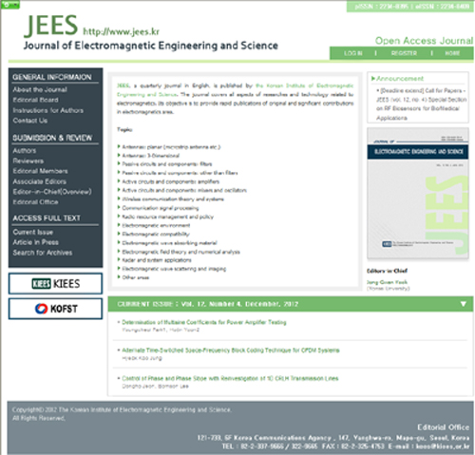
Fig. 1. Homepage of JEES. (Font size: 9.5)

sections for very high impedances and their application to branch-line hybrids with very weak coupling power," Journal of Electromagnetic Engineering and Science, vol. 9, no. 2, pp. 85-97, Jun. 2009.
Report
[3] E. E. Reber, R. L. Michell, and C. J. Carter, "Oxygen absorption in the earth’s atmosphere," Aerospace Corp., Los Angeles, CA, Tech. Rep. TR-0200 (4230-46)-3, Nov. 1988.
Conference Proceedings
[4] S. P. Bingulac, "On the compatibility of adaptive controllers," in Proceedings of the 4th Annual Allerton Conference on Circuit and System Theory, NewYork, pp. 8-16, 1994.
Papers Presented at Conferences
[5] J. G. Kreifeldt, "An analysis of surface-detected EMG as an amplitude-modulated noise," presented at the 8th International Conference on Medical and Biological Engineering, Chicago, IL, 1969.
[6] J. Arrillaga and B. Giessner, "Limitation of short-circuit levels by means of HVDC links," presented at the IEEE Summer Power Meeting, Los Angeles, CA, Jul. 1990.
Theses (M.S.) and Dissertations (Ph.D.)
[7] N. Kawasaki, "Parametric study of thermal and chemical nonequilibrium nozzle flow," M.S. thesis, Department of Electronic Engineering, Osaka University, Osaka, Japan, 1993.
[8] J. O. Williams, "Narrow-band analyzer," Ph.D. dissertation, Department of Electronic Engineering, Harvard University, Cambridge, MA, 1993.
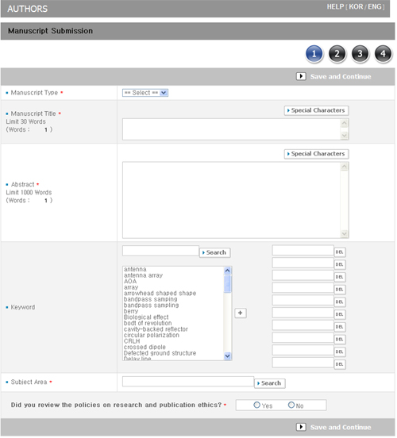
Fig. 2. The screen of manuscript submission.

Standards
[9] IEEE Criteria for Class IE Electric Systems, IEEE Standard 308, 1969.
Online Sources
[10] R. Bartle, "Early MUD History," Nov. 1990; www.ludd.luth.se/aber/mud-history.html.

Ⅱ. CONCLUSION
15. When citing any paper published in JEES, it should be indicated the name of the journal as Journal of Electromagnetic Engineering and Science or J. Electromagn. Eng. Sci.
16. Unit and Abbreviation: If the authors describe length, height, weight, and volume, they should use standard metric units. Temperature should be given in degrees Celsius. All other units should follow the International System of Units (SI). All units must be preceded by one space except percentages (%) and temperatures (°C).
Abbreviations must be used as an aid to the reader, rather than as a convenience of the author, and therefore their use should be limited. Generally, abbreviations that are used less than 3 times in the text, including tables and figure legends, should be avoided.
Standard SI abbreviations are recommended. Other common abbreviations are as follows (the same abbreviations are used for plural forms): h (hour), min
Table 1. All figures, figure captions, and tables can be at the end of the paper. Large figures and tables may span both columns. (Font size: 9.5)

Mij | 1 | 2 | 3
1 | -0.276 | 1.045 | -0.658
2 | 1.707 | 0.486 | 1.075
3 | -0.658 | 1.075 | -0.276
4 | 1.045 | -0.388 | 2.112
5 | -0.052 | 1.475 | 3.012
6 | 1.812 | 1.847 | 2.015
7 | -0.312 | 0.071 | -0.615

(minute), s (second), d (day), wk (week), mo (month), y (year), L (liter), mL (milliliter), μL (microliter), g (gram), kg (kilogram), mg (milligram), μg (microgram), ng (nanogram), pg (picogram), g (gravity; not g), nm (nanometer), μm (micrometer), mV (millivolt), mA (milliampere), mW (milliwatt), C (coulomb), μF (microfarad), mH (millihenry), n (samplesize), SD
(standard deviation of the mean), and SE (standard error of the mean).
17. Once the review process has been completed with a decision of acceptance, the final paper accommodating all of the reviewers’ comments should be submitted along with photos of the authors and their brief biographies (including major research areas).
18. The accepted papers will be published, in principle, in the order of initially received dates subject to decision of the editorial board.
19. For the published papers, 20 reprints without a cover will be provided to the authors without an additional charge.
20. The publishing charge for general publishing is 150,000 won (USD 150) for up to the first 6 pages. For 7 to 8 pages, an extra charge of 30,000 won (USD 30) per page, and for 9 pages or more, an extra charge of 40,000 won (USD 40) per page. Furthermore, the KIEES charges extra 100,000 won (USD 100) for the paper acknowledging a financial support from an institution, in addition to the above mentioned page charge.

APPENDIX

If needed, appears before the reference. Sponsorship or financial support acknowledgment should be included here.
REFERENCES
Please give as much information as possible [all authors, title, publication/book/conference name, vol. and issue (if relevant), page numbers, etc.]. All references must be referred to within the text (in numerical order).

photograph
2.5×3.0 cm

(Font size: 9) First Author and the other authors may include biographies at the end of regular papers. The author’s educational background is listed. The degrees should be listed with type of degree in what field, which institution, city, state, and country, and year degree was earned. The author’s major field of study should be lower-cased.
The current job must have a location; previous positions may be listed without one. Information concerning previous publications may be included. Current and previous research interests end the paragraph.
If a photograph is provided, the biography will be indented around it. The photograph is placed at the top left of the biography.

